1. Parsing the domain brings HTML parser structure

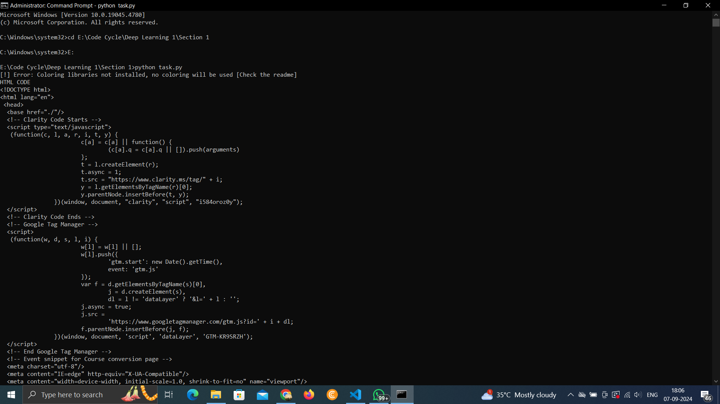

1. List the sub domains and with directories and files

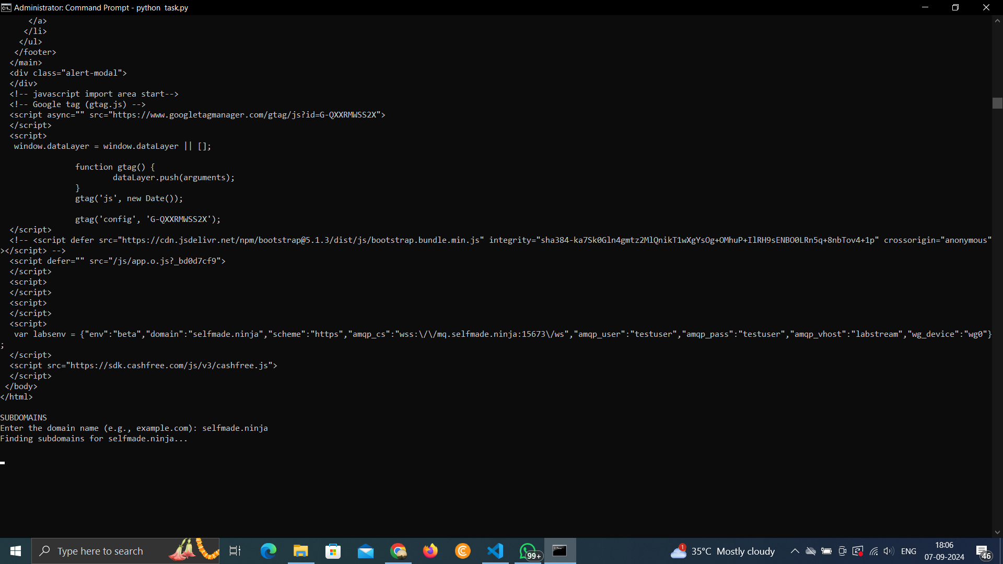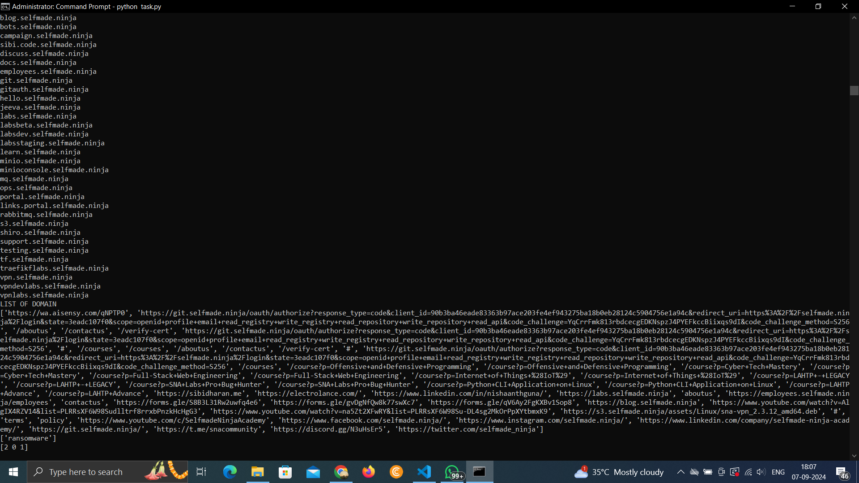

1. Through domain and sub domains take the cyber incidents news by parsing the list of words from listed top 10 Cybersecurity news website  
     
   